Test Case: tc002_SPX_Dev5_Crear_Requisicion_Spot_Tipo_Cobro_Project
Step 1 - Enter username and password and click to button Enter: Credentials Entered
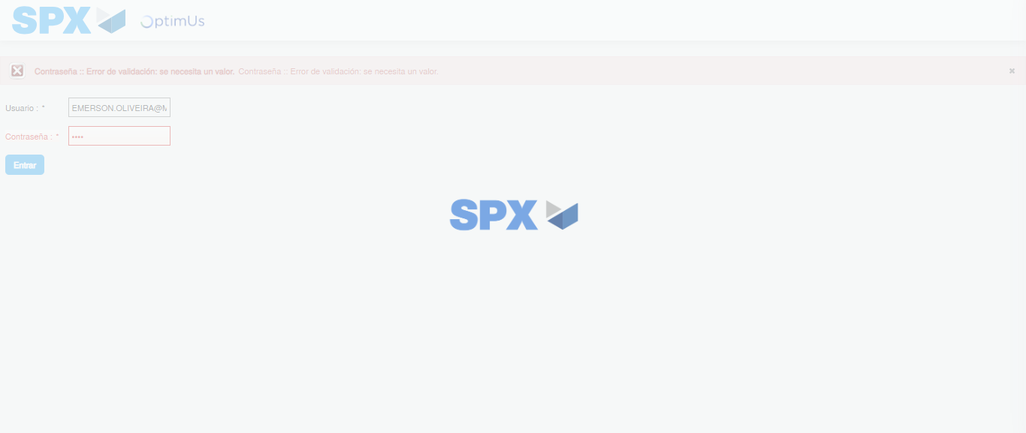Image file-name: QC_Testing-tc002_SPX_Dev5_Crear_Requisicion_Spot_Tipo_Cobro_Project-1785974401610

Step 2 - Select to UEN and Access to Spot Buy Requisitions : UEN Correctly selected and Correct access
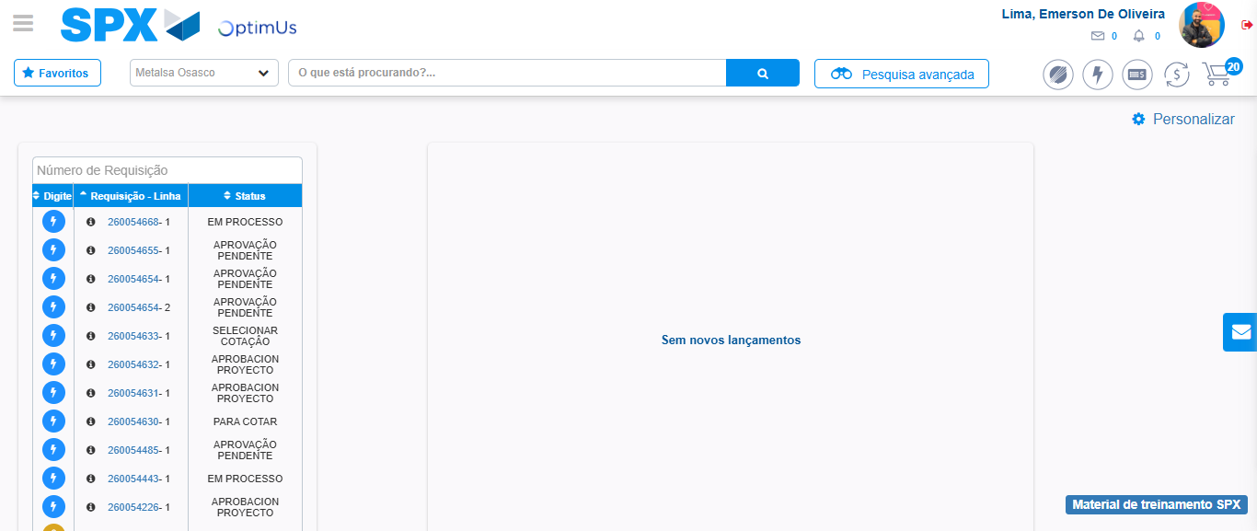Image file-name: QC_Testing-tc002_SPX_Dev5_Crear_Requisicion_Spot_Tipo_Cobro_Project-1785974426160

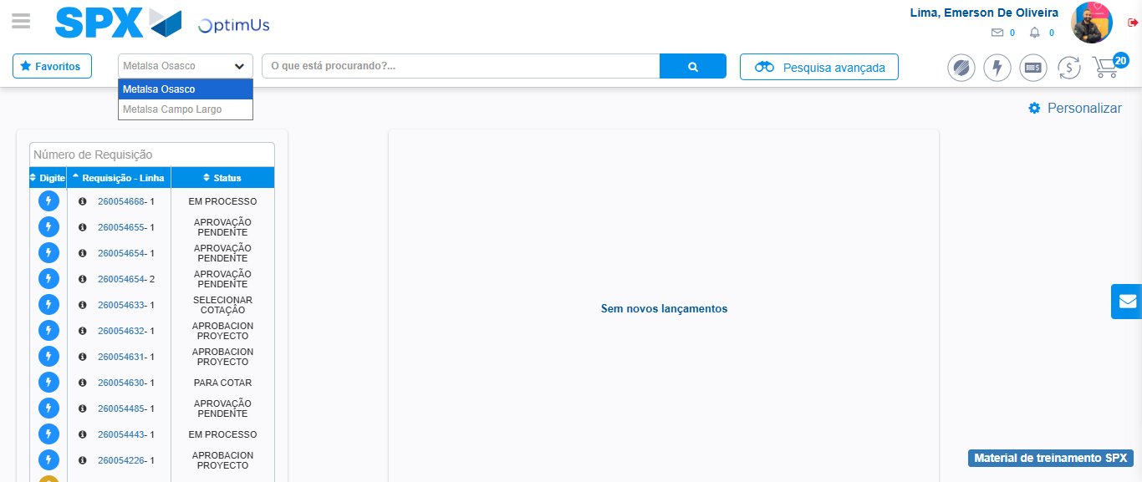Image file-name: QC_Testing-tc002_SPX_Dev5_Crear_Requisicion_Spot_Tipo_Cobro_Project-1785974428584

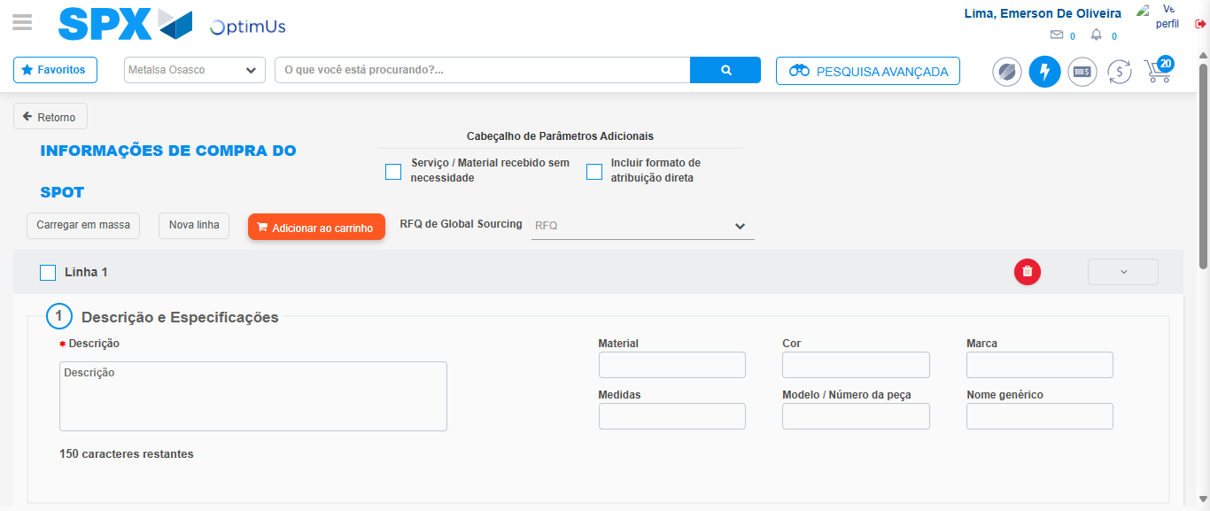Image file-name: QC_Testing-tc002_SPX_Dev5_Crear_Requisicion_Spot_Tipo_Cobro_Project-1785974432929

Step 3 - Data Capture Spot Buy Requisition: Data captured correctly
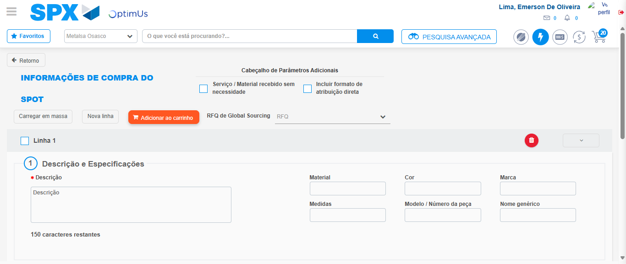Image file-name: QC_Testing-tc002_SPX_Dev5_Crear_Requisicion_Spot_Tipo_Cobro_Project-1785974433181

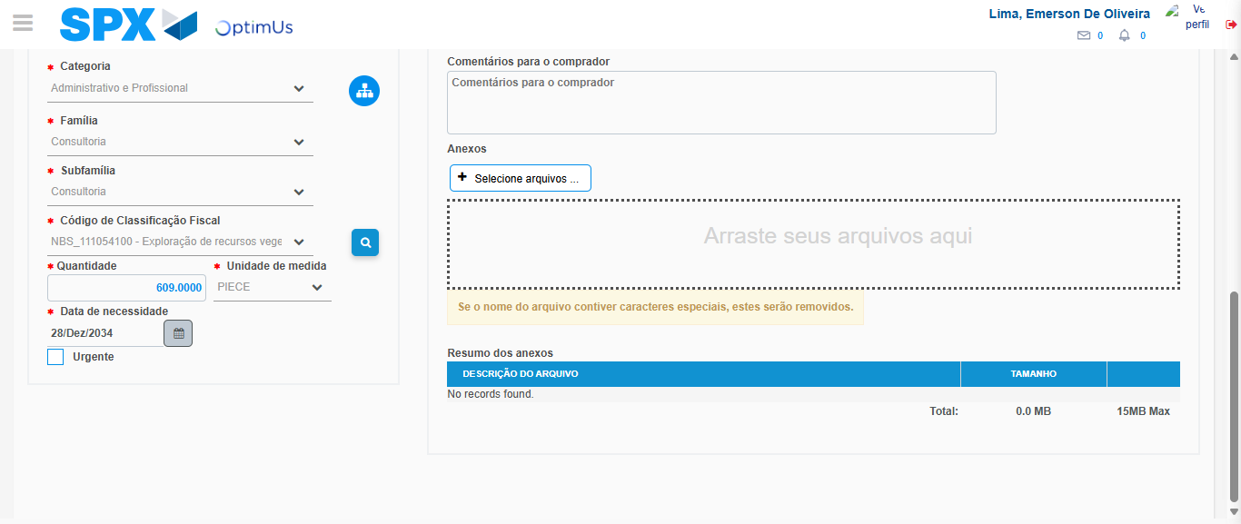Image file-name: QC_Testing-tc002_SPX_Dev5_Crear_Requisicion_Spot_Tipo_Cobro_Project-1785974448963

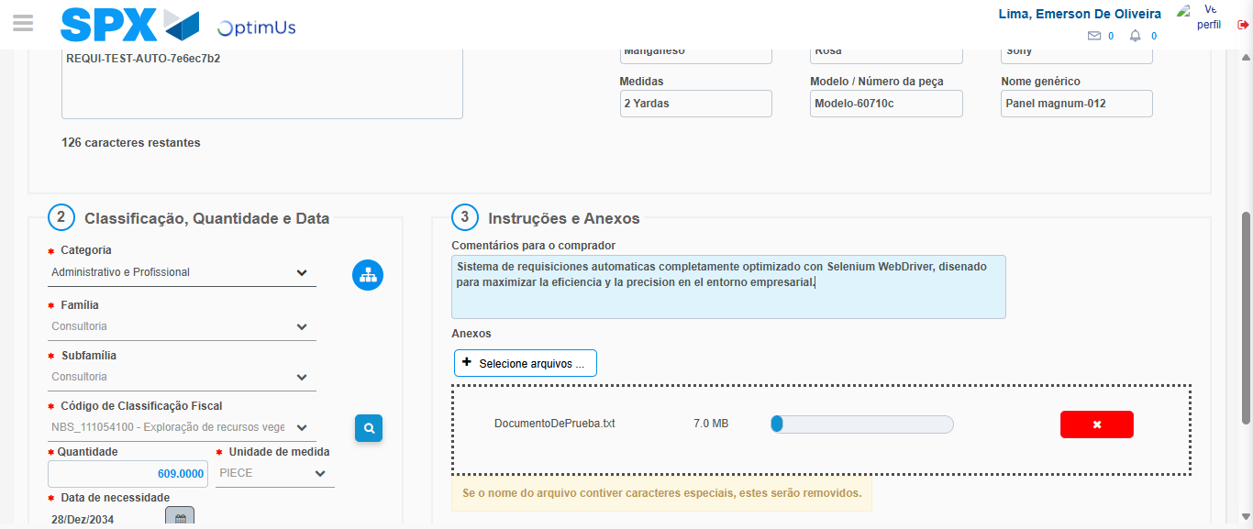Image file-name: QC_Testing-tc002_SPX_Dev5_Crear_Requisicion_Spot_Tipo_Cobro_Project-1785974449739

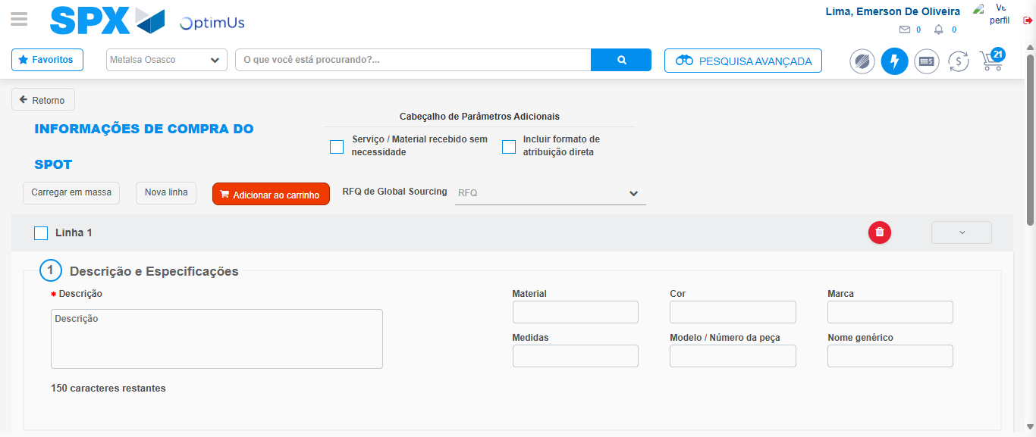Image file-name: QC_Testing-tc002_SPX_Dev5_Crear_Requisicion_Spot_Tipo_Cobro_Project-1785974454468

Step 7 - Return to Main Page SPX : Return to Main Page SPX
Image file-name: QC_Testing-tc002_SPX_Dev5_Crear_Requisicion_Spot_Tipo_Cobro_Project-1785974426160

Image file-name: QC_Testing-tc002_SPX_Dev5_Crear_Requisicion_Spot_Tipo_Cobro_Project-1785974428584

Image file-name: QC_Testing-tc002_SPX_Dev5_Crear_Requisicion_Spot_Tipo_Cobro_Project-1785974432929

Image file-name: QC_Testing-tc002_SPX_Dev5_Crear_Requisicion_Spot_Tipo_Cobro_Project-1785974456710

Image file-name: QC_Testing-tc002_SPX_Dev5_Crear_Requisicion_Spot_Tipo_Cobro_Project-1785974456859

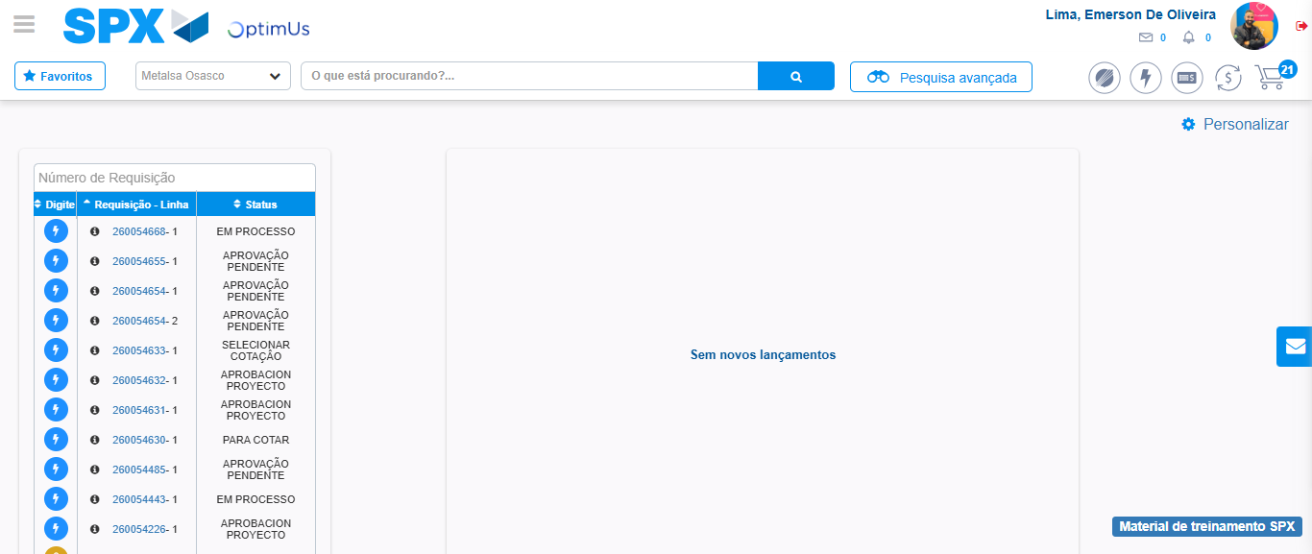Image file-name: QC_Testing-tc002_SPX_Dev5_Crear_Requisicion_Spot_Tipo_Cobro_Project-1785974478065

Step 8 - Log Out : Log Out SPX
Image file-name: QC_Testing-tc002_SPX_Dev5_Crear_Requisicion_Spot_Tipo_Cobro_Project-1785974478251

